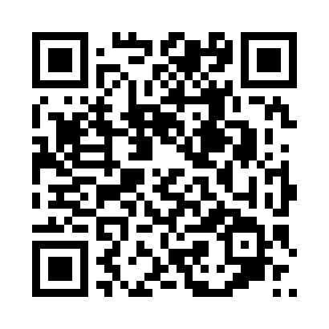

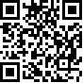

Lakewood Family and Children’s Centre

107 Raphael Cres, Frankston

Time: 1–2.30pm

Term 1 dates:

February 12, 19 and 26

March 5, 12, 19 and 26

April 2.

Please book via Try bookings:  
<https://www.trybooking.com/CYKHB>   
or use the QR code

## Benefits of coming to playgroup

* Meet other families
* Supportive environment
* Share ideas and information
* Have fun, relax and build friendships
* Introduce your baby to new surroundings
* Play and explore
* To find out more phone: 9293 7156 or email:   
  Elaine.Turner@frankston.vic.gov.au