

**Frankston City Council**

**Electric Line Clearance Management Plan**

**2022/23**

|  |  |  |  |
| --- | --- | --- | --- |
| **Revision Number:** | 6.0 | **Approved by:** | Phil Cantillon |
| **Document Number** | A4657343 | **Position:** | Chief Executive Officer |
| **Date Updated** | 30.03.2022 | **Signature:** |  |
| **Date Approved** | 31.03.2022 |

Contents

Regulation 9 - Preparation of a Management Plan 4

9(2) Preparation of a Management Plan by 31 March each year 4

9(4)(a) Name position address and telephone number of the responsible person. 4

9(4)(b) Name position address and telephone number of the individual who was responsible for the preparation of the management plan. 4

9(4)(c) Name position address and telephone number of the persons who are responsible for carrying out the management plan. 4

9(4)(d) Telephone Number of a Person who can be contacted in an Emergency that requires Clearance of a tree from an Electric Line 4

9(4)(e) Objectives of the Management Plan 5

9(4)(f) The Land to Which the Management Plan Applies by Inclusion of a map. 5

9(4)(g) Any hazardous bushfire risk areas and low bushfire risk areas in the land referred to in paragraph 9(4)(f) (as indicated on the map) 5

9(4)(h) The locationof each area that the responsible person knows contains a tree that the responsible person may need to cut or remove to ensure compliance with the Code and that is 6

(i) Indigenous to Victoria 6

(ii) Listed in the Planning Scheme to be of Ecological, Historical or Aesthetic Significance. 6

(iii) Trees of Cultural or Environmental Significance. 6

9(3)(i) The means which the Responsible Person is required to identify a Tree specified in paragraph 9(4)(h) 6

9(4)(j) The management procedures that the Responsible person is required to adopt to ensure compliance with the Code which - 7

(i) Must include details of the methods to be adopted for managing trees and maintaining a minimum clearance space as required by the Code; 7

Managing Trees 7

ii) For the purposes of determining a minimum clearance space in accordance with Division 1 of Part 3 of the code – A) Must specify the method for determining an additional distance that allows for conductor sag and sway; and B) May provide for additional distances to be determined for different parts of an electric line span: 8

9(4)(k) The procedures to be adopted if it is not practicable to comply with the requirements of AS 4373 while cutting a tree in accordance with the Code. 9

9(4)(l) A description of each alternative compliance mechanism in respect of which the responsible person has applied or proposed to apply, for the approval under clause 31 of the code. 9

9(4)(m) the details of each approval for an alternative compliance mechanism that- (i) the responsible person holds; and (ii) is in effect. 9

9(4)(n) A description of the Measures that must be used to assess the performance of the Responsible Person under the Management Plan 9

9(4)(o) Details of the Audit processes that must be used to determine the Responsible person’s compliance with the Code 10

9(4)(p) The qualifications and experience that the responsible person must require of the persons who are to carry out the inspection, cutting or removal of trees in accordance with the Code and the Electricity Safety (General) Regulations 2019; 11

9(4)(q)Notification and consultation procedures, including the form of the notice to be given in accordance with Division 3 of Part 2 of the Code: 12

9(4)(r) A procedure for the independent resolution of disputes relating to electric line clearance; 12

Flow Chart – Dispute resolution Process 13

9(4)(s) If Energy Safe Victoria has granted an exemption under regulation 11 relating to a requirement of the Code, details of the exemption or a copy of the exemption. 13

Regulation 10 – Obligations relating to management plans 14

Regulation 11 – Exemptions 14

SCHEDULE 1 – CODE OF PRACTICE FOR ELECTRIC LINE CLEARANCE 15

Part 1 - Preliminary 15

1. Definitions 15

2. Meaning of minimum clearance space 17

Part 2—Clearance responsibilities 18

Division 1—Roles of responsible persons 18

3. Responsible person must keep minimum clearance space clear of trees 18

4, 5, 6 & 7. Exceptions to minimum clearance 18

8. Responsible person may cut or remove hazard tree 18

9. Clearance space for Electric lines See 9(4)(j) 18

Division 2 – Manner of cutting and removing trees. 19

10. Cutting of tree to comply with Standard 19

11. Cutting or removal of indigenous or significant trees must be minimised. 19

12. Cutting or removing habitat for threatened fauna 19

13. Restriction on timing of cutting or removal if notification is required 19

14. Restriction on urgent cutting of trees 19

15. Restriction on urgent removal of trees. 19

Division 3 – Notification, consultation and dispute resolution 20

16. Responsible person must provide notification before cutting or removing certain trees 20

17. Responsible person must publish notice before cutting or removing certain trees 20

18. Responsible person must consult with occupier or owner of private property before cutting or removing certain trees 20

19. Notification and record keeping requirements for urgent cutting or removal 20

Division 4 – Additional duties of responsible persons 20

20. Duty relating to the safety of cutting or removal of trees close to an electric line 20

Appendices 21

Appendix 1 - Declared Urban Area of Frankston City Council 21

Appendix 2 - High Bushfire Risk Area (HBRA) of Frankston City 22

22

Appendix 3: Register of Significant Trees on Public Land – Current 23

Appendix 4 - Two Year Cyclic Pruning Schedule 24

Appendix 5 - Map of 24 Road Management Plan (RMP) zones 25

Appendix 6 - Maintaining a minimum clearance space 26

Figure 1 – Plan view of Electrical lines in all areas 26

26

Figure 2 – Insulated Electric lines in all areas 26

Figure 3 – Insulated Electric lines in all areas and uninsulated high voltage electric lines (other than 66,000 volt electric lines) in Low Bushfire Risk Area 26

Graph 4: Uninsulated 66,000 volt electric line in Low Bushfire Risk Area 26

Appendix 6 - Predominate FCC tree species regrowth pruning guidance chart 27

Appendix 7 – United Energy Audits of FCC compliance and cost for non-compliance 28

Appendix 8 - Frankston City Council Location and Records of power line audits 29

8A- Municipality map showing historic data and current power line audit sites 29

8B - Zoomed in map of unique location of trees including pre-works inspection for electrical line clearance rectification 30

8C - Extract from Asset management system post-work generated audit 31

Appendix 9 - Staff training matrix example 32

Appendix 10 – Field Audits and KPI’s 33

10A - Monthly field Audit example 33

10B - Table example outlining contract program KPIs 34

Appendix 11 - Resident notification letters & tree maintenance web page 35

*This Electric Line Clearance Management Plan has been formatted to align to the structure of the Electrical Safety (Electric Line Clearance) Regulations 2020.*

# Regulation 9 - Preparation of a Management Plan

The following sections describes Frankston City Council compliance regarding the Electricity Safety (Electric Line Clearance) Regulations 2020.

## 9(2) Preparation of a Management Plan by 31 March each year

Before 31 March in each year, a responsible person must ensure that a management plan relating to compliance with the Code for the next financial year is prepared. The responsible person name in 9.3(b) will ensure that Council’s ELCMP is prepared before 31 March each year and submitted to ESV within 14 days of request. The ELCMP will be internally reviewed, amended and authorised before 31 March each year

## 9(4)(a) Name position address and telephone number of the responsible person.

|  |  |
| --- | --- |
| **Name:** | Phil Cantillon |
| **Position:** | Chief Executive Officer |
| **Business Address** | Civic Centre, 30 Davey Street, Frankston, PO Box 490 Frankston VIC 3199 |
| **Telephone** | 1300 322 322 |
| **E-mail** | info@frankston.vic.gov.au |

## 9(4)(b) Name position address and telephone number of the individual who was responsible for the preparation of the management plan.

|  |  |
| --- | --- |
| **Name:** | Brad Hurren |
| **Position:** | Manager Operations |
| **Business Address** | Civic Centre, 30 Davey Street, Frankston, PO Box 490 Frankston VIC 3199 |
| **Telephone** | 1300 322 322 |
| **E-mail** | info@frankston.vic.gov.au |

## 9(4)(c) Name position address and telephone number of the persons who are responsible for carrying out the management plan.

|  |  |
| --- | --- |
| **Name:** | Aaron Richardson |
| **Position:** | Section Leader Tree Maintenance |
| **Business Address** | Civic Centre, 30 Davey Street, Frankston, PO Box 490 Frankston VIC 3199 |
| **Telephone** | 1300 322 322 |
| **E-mail** | info@frankston.vic.gov.au |

## 9(4)(d) Telephone Number of a Person who can be contacted in an Emergency that requires Clearance of a tree from an Electric Line

|  |  |
| --- | --- |
| **Name:** | Frankston City Council, Emergency After Hours (All Hours) |
| **Telephone** | 1300 322 322 |

## 9(4)(e) Objectives of the Management Plan

**The following objectives and commitments are identified Frankston City Council in this ELCMP to fulfil the duties as set out under the Electrical Safety (Electric Lines Clearance) Regulation 2020 and the Code of Practice for Electrical Lines.**

* **Compliance to this plan and the Electrical Line Clearance Regulations 2020** will maintain a safer environment for the public, community and electricity distribution within Frankston City Council FCC. This will be achieved by the ongoing management and performance measurement of works undertaken on trees near power lines to meet this regulation.
* **To provide a safer working environment for FCC employees and contractors** by the adherence to all regulations, codes, practices and training requirements of Electrical Line Clearance Regulations 2020.
* **To ensure electricity companies can provide a reliable supply**. Frankston City Council will maintain ongoing dialog, audits, mapping and system reviews with delegates from United Energy UE Country Fire Authority CFA and Energy Safe Victoria ESV.
* **To maintain, protect and minimise impact to significant vegetation**, of historical aesthetic and ecological value, tree health and habitat of threatened species where it may be affected by electric lines.
* **To improve the communities understanding** of electric line clearance and vegetation needs by providing community information and consultation.
* **To minimise potential fire risk** by complying with Council’s Municipal Fire Management Plan.

The commitment by Frankston City Council’s managers, Arborists and its contractors to this ELCMP is to adhere to the regulations. Evidence of this will be measured by line clearing contactor KPIs, contractor audits, and post work inspections verified by FCC officers.

## 9(4)(f) The Land to Which the Management Plan Applies by Inclusion of a map.

Within the municipal boundaries of Frankston City Council are Energy Safe Victoria ESV declared areas, these generally being the limit of urban growth in 1983. This plan includes all trees located on Council managed land and road reserves within these declared areas that grow in the vicinity of electric lines. GIS tree survey data shows there are 68,500 trees within FCC streets and 34,000 of these are within the declared areas. GIS data shows FCC has some 8000 trees which require electric line clearance or approximately 4000 trees per annum under this plans two year cycle. Council will correspond and meet. Maps of the Frankston City Council Municipal boundaries and Declared Urban Area are included in Appendix 1 - Declared Urban Area of Frankston City Council

## 9(4)(g) Any hazardous bushfire risk areas and low bushfire risk areas in the land referred to in paragraph 9(4)(f) (as indicated on the map)

Council will correspond and meet with the CFA and ESV annually to check map data updates and changes to the Low Bushfire Risk Areas (LBRA) and High Bushfire Risk Areas (HBRA) within the declared are of Frankston Council. This was last completed on 2 December 2020 with updated maps included in Appendix 2 - High Bushfire Risk Area (HBRA) of Frankston City

## 9(4)(h) The locationof each area that the responsible person knows contains a tree that the responsible person may need to cut or remove to ensure compliance with the Code and that is

### (i) Indigenous to Victoria

For the purpose of this plan, Frankston City Council considers trees and shrubs *indigenous* to the area. Frankston City Council has a mix of indigenous species throughout the Declared Urban areas as described in the 2006 vegetation study.

<https://www.frankston.vic.gov.au/Environment-and-Waste/Environment/Biodiversity/Native-Flora>

### (ii) Listed in the Planning Scheme to be of Ecological, Historical or Aesthetic Significance.

There are various areas within Frankston City protected under the Frankston Planning Scheme for their ecological, historical or aesthetic value. These are detailed in the Planning Scheme under the Significant Landscape Overlay (SLO), Environmental Significance Overlay (ESO) or Heritage Overlay (HO), and their respective schedules. Details of these can be found in the Planning Scheme documents on the public record. Sites of significant roadside vegetation are also identified by installed signage. If further clarity is required inquiry to Frankston City will provide guidance to locations.

<http://www.frankston.vic.gov.au/Planning_and_Building/Planning>

### <https://www.frankston.vic.gov.au/Environment-and-Waste/Environment/Trees/Trees-Register-on-Public-Land>

### (iii) Trees of Cultural or Environmental Significance.

Trees on Council lands roads or public land maybe protected under a Local Law or Planning controls. In addition to this Council maintains Register of Significant roadsides vegetation. See Appendix 3: Register of Significant Trees on Public Land – Current

<https://www.frankston.vic.gov.au/Environment-and-Waste/Environment/Trees/Local-Laws-for-Trees>

<https://www.frankston.vic.gov.au/Planning-and-Building/Planning/Request-a-planning-enforcement-investigation>

## 9(3)(i) The means which the Responsible Person is required to identify a Tree specified in paragraph 9(4)(h)

Council and it’s contractors can identify trees referred to in section (g) of the Plan that are; (i) indigenous, (ii) listed in a planning scheme to be of Ecological, Historical or Aesthetic Significance or (iii) of Cultural or Environmental Significance by checking & verifying their inclusion in;

* Council planning scheme overlay for historical, cultural, environmental or aesthetic significance see:

<http://planning-schemes.delwp.vic.gov.au/schemes/frankston/maps>

* The Victorian Aboriginal Heritage Register established under the Aboriginal Heritage Act 2006 see:

<https://www.firstpeoplesrelations.vic.gov.au/victorian-aboriginal-heritage-register>

* Flora or habitat of fauna listed as threatened in accordance with section 10 of the Flora and Fauna Guarantee Act 1988 see:

<https://www.environment.vic.gov.au/conserving-threatened-species/victorias-framework-for-conserving-threatened-species>

* Flora listed in the Threatened Flora List with a conservation status in Victoria of ‘endangered’ or ‘vulnerable’ or ‘critically endangered’ see: <https://www.environment.vic.gov.au/conserving-threatened-species/threatened-list>

Council routinely reviews these overlays and registers. Prior to this ELCMP annual submission they will be checked to ensure they are current and accurate. Frankston City Council staff, contractors, local authorities and distribution businesses will be informed of these overlays, registers and associated updates so they a have current and clear understanding of the location of these trees and vegetation. Frankston City Council Operation Department manages and monitors areas of high value vegetation and reports on noncompliance to the above Acts and Regulations to Frankston City Council Planning and Environment department.

## 9(4)(j) The management procedures that the Responsible person is required to adopt to ensure compliance with the Code which -

### Must include details of the methods to be adopted for managing trees and maintaining a minimum clearance space as required by the Code;

### Managing Trees

Frankston City Council has adopted a formal approach to managing trees within the Declared Urban Area requiring all trees to be assessed and pruned to provide adequate power line clearance for species regrowth over a two year cycle.

See Appendix 4 - Two Year Cyclic Pruning Schedule and Appendix 5 - Map of 24 Road Management Plan (RMP) zones.

Data collected over a 14 year span show Frankston City Council has 34,000 trees within the declared areas. From this data it’s also known that some 8000 trees require line clearance or 4000 trees per annum under the 2 year cycle. Frankston City Council has divided its region into 24 Roads Management Plan (RMP) Zones and each zone is GIS pre audited for required tree clearance works. Using the minimum clearance space for two years regrowth, as per Appendix 6 - Maintaining a minimum clearance space*.* Observed line clearance work are logged & preserved in the GIS data base and from this a work zone pack is extracted and issued to Power line Vegetation Control ESI trained contractors. During each month regular and random zone site inspections are undertaken by a Council Arborist and Council Contract Supervisor to ensure correctly trained and qualified personal are undertaking the pruning work. Frankston City Council Officers meet and liaise regularly with the United Energy vegetation representative. On a needs basis Council will liaise with Metro Trains (1800 800 007, PO Box 1880 Melbourne VIC 3000) as a rail corridor runs though Frankston. The minutes of these meetings and outcomes are filed and preserved in our records management system.

**Managing and recording regrowth**

Additional RMP zone tree inspections continually occur throughout Frankston City Council as some species of trees are known to regrow beyond predicted or accepted rates. Please see table Appendix 6 - Predominate FCC tree species regrowth pruning guidance chart. Trees identified with high regrowth rate will be reactively pruned to maintain correct clearance and trees that habitually trespass line clearance space will be considered for removal and replacement. Any notification of non-compliant trespass by tree limbs will be inspected within two days and rectified to secure or clear by ESI trained personnel within 14 days.

Each year prior to summer fire declaration Frankston City Council Arborist will inspect audit and report upon the compliance of vegetation in its areas of HBRA. This filed report with dated photographs is supplied to ELCMP managers and the Distribution Business (DB), United Energy (UE) to confirm these areas have been observed and works undertaken to ensure line clearance compliance.

**Council street scape & tree planting strategy**

The removal of inappropriate species and planting of suitable street trees species within the vicinity of overhead electric lines is drawn from Council's approved Street Tree Master Plan 2006. This Plan can be found on Council's website at the link below.

[Frankston City Council - Street Tree Master Plan](https://www.frankston.vic.gov.au/files/assets/public/environment-and-waste/environment/trees/pdfs/street_tree_master_plan_report_jan_2007.pdf)

### For the purposes of determining a minimum clearance space in accordance with Division 1 of Part 3 of the code – A) Must specify the method for determining an additional distance that allows for conductor sag and sway; and B) May provide for additional distances to be determined for different parts of an electric line span:

Generally the overall distance of power line bays within the declared areas of Frankston City Council will not require sag or sway estimation as per 2020 regulations. There are four bays of high voltage 66kv spans over 45m distance and these have been identified as having high sag and sway potential in conditions of heat and/or wind. This can be found outside Monash University in LBRA where a 66kv line runs south along Moorooduc Rd to Golf links road. With this knowledge, the vegetation clearance of these line bays shall be kept greater and the determination will be via Appendix 6 - Maintaining a minimum clearance space – Graph 4 formula for sag and sway for uninsulated 66kv electric line in Low Bushfire Risk Area. The minimum clearance distance is determined to be 2250 millimetres.

Frankston City will consult with its United Energy delegate Council Liaison Officer CitiPower, Powercor & United Energy Ph, 9683 4851 to further determine sag and sway clearance requirement. These sag and sway actions and determination records shall be kept on file for five years. Frankston City Tree Contactors are kept informed of these spans with higher needs and they shall be annually audited as part of Councils pre summer fire season HBRA zone declaration compliance. This audit report is supplied to UE and saved Council correspondence files preserved for over five years.

## 9(4)(k) The procedures to be adopted if it is not practicable to comply with the requirements of AS 4373 while cutting a tree in accordance with the Code.

Frankston City tree contractors and internal staff are required to prune to the Australian Standard Pruning of amenity trees AS4373 (2007) utilising current arboricultural education and training for amenity tree pruning techniques and the works quality are regularly inspected. This expertise combined with the use of industry benchmarks, appropriate and compliant tested plant and equipment will as far as practicable ensure proper tree clearing methods and public’s safety.

It’s not expected that Council tree contractors will be unable to comply with AS4373. If any case arises the Arborist will inspect and determine best action for compliance to the regulations while considering the health and safety of the trees concerned. In reference to AS4373 “practicable” means works which is or was at the time reasonable or practicable to be done in relation to securing the trees health and safety. This definition shall be provided to ELC program personal via the contract specification and meetings

## 9(4)(l) A description of each alternative compliance mechanism in respect of which the responsible person has applied or proposed to apply, for the approval under clause 31 of the code.

No exemptions are applied or expected to be applied for by Frankston City Council. Alternative measures or methods if required to keep these clearance spaces free of vegetation may include undergrounding, installation of Aerial Bundled Conductors (ABC), alternative placement of electric lines, removal and replacement of problem species, adopting higher frequency inspections and pruning maintenance cycles.

## 9(4)(m) the details of each approval for an alternative compliance mechanism that- (i) the responsible person holds; and (ii) is in effect.

This section is not applicable, no alternative compliance mechanisms are expected to be applied as per section 9(4)(l)

## 9(4)(n) A description of the Measures that must be used to assess the performance of the Responsible Person under the Management Plan

Performance measures for the implementation of the plan are:

* Preparation of ELCMP by 31 March annually.
* Audit report and filing of HBRA compliance areas within Frankston by 1st November
* Number of pruning requests from the distribution company to be stable or deceasing
* Number of valid line pruning requests from the community to be stable or decreasing
* Satisfactory audit of Council’s Tree Maintenance Contractor’s Compliance with the code
* Audit report by UE showing FCC ratings out of 14 ORP within its network see Appendix 7 – United Energy Audits of FCC compliance and cost for non-compliance.
* Adherence to the tree contract specification and measures to audit and meet monthly KPI targets

These records are kept in Council’s Customer Service Requests PCS and REM correspondence database and its GIS tree inventory system.

Frankston City Council GIS tree data collection allows its Arborist to interrogate and interpret to individual tree and species level. This technical ability can be used to predict trends and identify areas of improvement or opportunity.

## 9(4)(o) Details of the Audit processes that must be used to determine the Responsible person’s compliance with the Code

Trees within the declared zones of Council are GIS inspected by a qualified Arborist for noncompliance and corrective clearance works orders completed. When each zone is completed a post work audit is then undertaken by the contractor checking trees for compliance and regrowth clearances and this is supplied back to Arborist.

Council utilizes the FAMIS/FieldGo Asset Management software system that generates a random 20 % post zone audit each month, examples are found in Appendix 8 - Frankston City Council Location and Records of power line audits. This illustrates how the data is displayed and the systems requirement to visit each sites and observe correct tree clearance before each unique job is closed, dated and electronically recorded as satisfactory completed.

If any noncompliance of vegetation and power lines is observed within the zone work areas it’s then extracted and returned to the contractor with 14 days to rectify.

The audit and work performance results are discussed during monthly contract meetings and saved into Council’s Electronic Document Management System. Contractors are required to address any areas of noncompliance identified within 14 working days.

Auditing and inspection of contractor staff HSE is undertaken by the Council’s Arborist with qualifications and competency checked and field tested in work site inspections and emergency scenarios. These site inspections are filed into a record system/contract management. See Appendix 9 - Staff training matrix example and Appendix 10 – Field Audits and KPI’s

Council annually issues customer satisfaction surveys to the public and the response can benefit future work planning and programing.

## 9(4)(p) The qualifications and experience that the responsible person must require of the persons who are to carry out the inspection, cutting or removal of trees in accordance with the Code and the Electricity Safety (General) Regulations 2019;

The Council contract specification requires that all work conducted on trees is completed by trained staff with qualifications in Arboriculture and the Electrical Safety (General) Regulations 2019 - Regulation 616:

1. *A person (other than a qualified person) must not carry out vegetation management work if the vegetation is closer to a protected aerial line set out in column 1 of Table 616 than the relevant minimum distance specified in column 2 or 3 of that Table that corresponds to that aerial line*

***Table 616 – Minimum distances of vegetation from protected aerial lines for persons (other than qualified persons) carrying out vegetation management work***

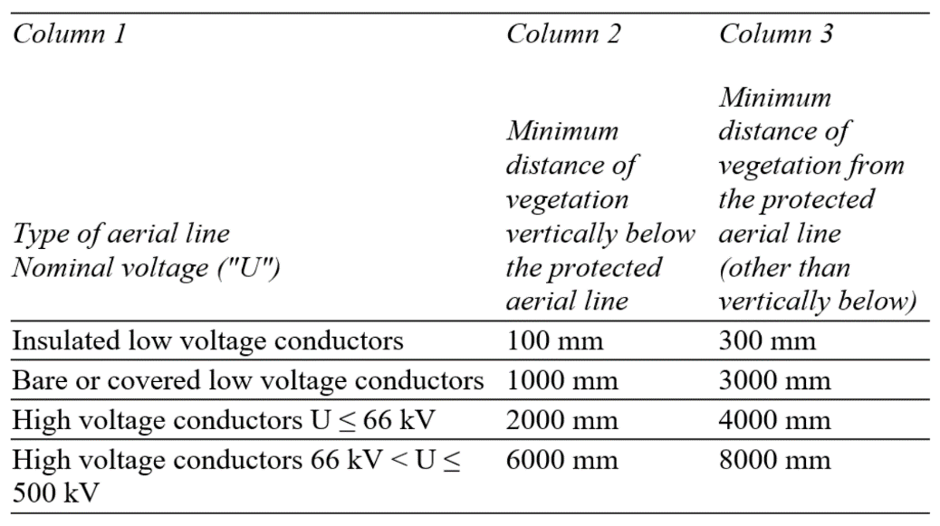

1. A *qualified person carrying out vegetation management work in the vicinity of a protected aerial line must comply with –*
2. *The vegetation management rules; and*
3. *The Blue Book when working on or near high voltage electrical equipment; and*
4. *The Orange Book when working on or near a railway or tramway supply network.*
5. *In this regulation, “qualified person” means a person who holds a current certificate that is approved by Energy Safe Victoria specifying satisfactory completion of a training course in tree clearing.*

Frankston City Council requires expertise, quality management, OH&S systems and environmental management systems of its contractors and internal staff to ensure compliance with Council's contract specifications and Industry Standards. All pruning under this Plan will comply with Australian Standard 4373-2007 Pruning of Amenity Trees as a minimum. All persons pruning trees under this Plan must be inducted into the system and kept current by annual refresher training the following:

* Appropriate qualifications and experience or level 3 Horticulture (Arboriculture) certificate or an equivalent is preferred at a minimum OHS white card or equivalent.
* Certificate II in ESI Power line Vegetation Control and work role electives
* Manual Handling. Noise conservation training. First Aid, Chainsaws Operation Elevating Work Platform (EWP) Emergency procedures including (EWP) escape training. Branch Chipper Operation Worksite Traffic Management
* All Contract Supervisors must in addition to the above have successfully completed and kept current a Certificate V in Arboriculture or higher.
* Records of qualifications for all staff undertaking works on Council trees are checked randomly and annually with files kept in Council's Electronic Document Management System. Any deficiency found in compliance to these qualification requirements maybe addressed by direct removal of staff from work site or by the contract performance auditing
* Personnel training details are recorded in a training matrix available upon request. An except exampled is included in Appendix 9 - Staff training matrix example

## 9(4)(q)Notification and consultation procedures, including the form of the notice to be given in accordance with Division 3 of Part 2 of the Code:

Frankston City Council's tree maintenance contractors are required to inform residents affected by tree pruning/removal for electric line clearance by media advertisement or a notification letter prior to works.In the case of trees of environmental significance that require pruning/removal for the purpose of electric line clearance the tree maintenance contractor is required to notify Council, including the details of the impact the cutting or removal would have and the action taken to minimize impact.

Affected persons will be notified at least 14 days prior and no longer than 60 days before work is to commence via placement of notice into FCC Website, FCC Facebook and letterbox delivery of Contractor notification.See Appendix 11 - Resident notification letters & tree maintenance web page

## 9(4)(r) A procedure for the independent resolution of disputes relating to electric line clearance;

If a member of the public has a concern or dispute with Council over it’s actions under this Plan they may review the document and its obligations at Frankston City principle office or via electronic copy available on Frankston City Council’s website. Applications for dispute will be referred Frankston City Councils Manager of Operations. If the Manager cannot remedy or resolve the complaint it will be escalated through Council's internal dispute resolution system.

Where a dispute cannot be resolved directly between a member of the public and Council, Council will recommend that the person take their concerns to the Energy and Water Ombudsman of Victoria. Council will participate in any investigation or negotiation established by these external parties.

**Energy and Water Ombudsman** – 1800 500 509, Reply paid 469, Melbourne VIC 8060.

### Flow Chart – Dispute resolution Process

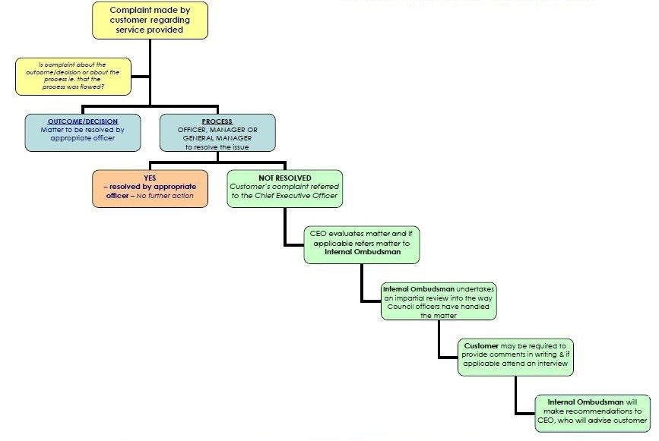

## 9(4)(s) If Energy Safe Victoria has granted an exemption under regulation 11 relating to a requirement of the Code, details of the exemption or a copy of the exemption.

This section is not applicable to Frankston City Council, no exemptions apply.

# Regulation 10 – Obligations relating to management plans

10(1) This regulation applies in relation to the management plan that a responsible person is required to prepare under regulation 9.

10(2) The responsible person must provide a copy of the management plan to Energy Safe Victoria within 14 days after a written request from Energy Safe Victoria or such longer period as specified by Energy Safe Victoria in the written request.

10 (3) The responsible person, if requested in writing to do so by Energy Safe Victoria, must provide further information or material in respect of the management plan within 14 days after the written request or such longer period as specified by Energy Safe Victoria in the written request.

10(4) The responsible person must amend the management plan if instructed to do so in writing by Energy Safe Victoria within 14 days after the written instruction or such longer period as specified by Energy Safe Victoria in the written instruction.

10(5) The responsible person must not contravene a requirement of the management plan if the management plan is approved by Energy Safe Victoria.

10(6) The responsible person must ensure that a copy of the current management plan is published on the responsible person's Internet site.

**A copy of Council’s Electric Line Clearance Plan is available on the Frankston City Council website**

**[Frankston City Council - Electric Line Clearance Management Plan](https://www.frankston.vic.gov.au/Environment-and-Waste/Environment/Trees/Tree-Maintenance-Program)**

# Regulation 11 – Exemptions

11(1) Energy Safe Victoria May exempt a Responsible person from any of the requirements of these Regulations subject to any conditions specified by Energy Safe Victoria.

11(2) A responsible person who is granted an exemption under this regulation must comply with the conditions (if any) of the exemption.

**Frankston City Council has not applied for or been granted any exemptions under regulation 11**

## 

# SCHEDULE 1 – CODE OF PRACTICE FOR ELECTRIC LINE CLEARANCE

# Part 1 - Preliminary

## Definitions

**Aerial bundled cable -** means an insulated conductor manufactured in accordance with the specifications set out in any of the following—

1. AS/NZS 3560.1 as published or amended from time to time;
2. AS/NZS 3560.2 as published or amended from time to time;
3. AS/NZS 3599.1 as published or amended from time to time;
4. AS/NZS 3599.2 as published or amended from time to time;

**Conductor Spreader -** means an insulated rod used to maintain distance between uninsulated conductors of an aerial low voltage electric line;

**Covered conductor** - means an insulated conductor manufactured in accordance with the specifications set out in AS/NZS 3675 as published or amended from time to time;

**Electrical cable -** means an insulated conductor manufactured in accordance with—

1. the specifications set out in AS/NZS 1429.1 as published or amended from time to time; or
2. the specifications set out in AS/NZS 1429.2 as published or amended from time to time;

**Electric line span** - means the section of the electric line between 2 adjacent supporting structures;

**Extra low voltage** - means a voltage not exceeding—

1. 50 volts alternating current; or
2. 120 volts ripple-free direct current;

**Insulated cable -** means a conductor insulated by a medium other than air and includes any of the following—

1. aerial bundled cable;
2. covered conductor;
3. electric cable;
4. a conductor to which an insulating cover has been applied;

**Insulating cover** - means an insulating pipe or tube that is—

1. applied to a conductor to provide a protective barrier; and
2. manufactured in accordance with the specifications set out in any of the following—
3. AS IEC 60060.1 as published or amended from time to time;
4. AS IEC 60060.2 as published or amended from time to time;
5. AS 4202 as published or amended from time to time;
6. AS/NZS 3100 as published or amended from time to time;
7. AS/NZS 3121 as published or amended from time to time;

**Low voltage** - means a voltage exceeding extra low voltage but not exceeding—

1. 1000 volts alternating current; or
2. 1500 volts direct current;

***Minimum clearance space*** has the meaning set out in clause 2;

**Nominal voltage** - means the voltage at which the electric line is designed to operate;

**Published technical standard** - means a document giving technical information, guidance or advice published by—

* 1. Standards Australia; or
  2. Standards New Zealand; or
  3. the British Standards Institution; or
  4. the International Organisation for Standardisation; or
  5. the International Electrotechnical Commission; or
  6. any similar standards organisation within or outside Australia approved by Energy Safe Victoria; or
  7. Energy Safe Victoria;

**Railway supply network -** means the supply network of a railway;

*Note railway and supply network*are defined in section 3 of the Act.

**Sag** - in relation to a conductor, means the vertical displacement of the conductor below the point at which the conductor is attached to the supporting structure and includes any additional displacement caused by hot weather or high load current;

**Span distance** - means the distance between the points at which an electric line span is attached to the 2 adjacent supporting structures;

**Suitably qualified arborist -** means an arborist who has—

* 1. as a minimum, the qualification of National Certificate III in Arboriculture including the "Perform a ground-based tree defect evaluation" unit of competency, or an equivalent qualification; and
  2. at least 3 years of field experience in assessing trees;

**Sway** - in relation to a conductor, means the horizontal displacement of the conductor caused by wind;

**Tramway supply network** - means the supply network of a railway that is a light railway or tramway;

**Transmission line** - means an electric line—

* 1. with a nominal voltage of more than 66,000 volts; or
  2. operating at 66 000 volts that is supported on tower structures; or
  3. operating at 66,000 volts that is adjacent to an electric line that has a nominal voltage greater than 66,000 volts;

**Uninsulated cable** - means a conductor that is not an insulated cable.

## Meaning of minimum clearance space

1. Except as otherwise provided by this clause, the ***minimum clearance space*** for an electric line span is the minimum clearance space for the span as determined under Part 3.
2. For the purposes of the application of this Code to a responsible person who holds an [approval for an alternative compliance mechanism](http://www.austlii.edu.au/cgi-bin/viewdoc/au/legis/vic/consol_reg/eslcr2020474/s5.html#approval_for_an_alternative_compliance_mechanism) that is in effect—
   1. if the approval applies to a particular electric line span—the ***minimum clearance space*** for that span is the minimum clearance space specified in the approval under clause 33(3)(d)(i); or
   2. if the approval applies to a class of electric line span—the ***minimum clearance space*** for each span that belongs to that class is the minimum clearance space specified in the approval under clause 33(3)(d)(i).

# Part 2—Clearance responsibilities

## Division 1—Roles of responsible persons

## 3. Responsible person must keep minimum clearance space clear of trees

A responsible person must ensure that, at all times, no part of a tree for which the person has clearance responsibilities is within the minimum clearance space for an electric line span.

## 4, 5, 6 & 7. Exceptions to minimum clearance

No exception is requested or proposed by Frankston City Council for period of this ELCM operation for clause 4, 5, 6 or 7.

## 8. Responsible person may cut or remove hazard tree

Frankston City Council ensures that all trees are assessed by a suitably qualified Arborist holding a minimum Certificate IV in Arboriculture, including the ‘Assess Trees’ module, or equivalent and 5 years of field experience in hazard tree assessment. Each assessment takes into consideration all foreseeable environmental and weather conditions and anticipated vegetation regrowth. If that assessment confirms the likelihood of contact with electric lines the tree will be pruned or removed or the threatening parts secured.

Frankston City Council meets it’s obligations under Section 86B of the Electricity Safety Act 1998 (Vic) by undertaking an annual rural roadside audit. Works identified as high risk are GIS logged and maybe immediately secured or the task passed on to the responsible owner authority or distribution company.

Council Contractors and in-house crews are suitably qualified for assessment and pruning of tree limbs under power lines. After undertaking the urgent work the contractor is responsible for notifying all affected persons. The contractor will record the details of the work undertaken, including why, when, and where the cutting or removal was undertaken. A responsible person that undertakes urgent work must not remove or prune trees further than one meter from the minimum clearance space around electricity lines.

## 9. Clearance space for Electric lines See 9(4)(j)

See Regulation 9(4)(j) above.

## Division 2 – Manner of cutting and removing trees.

## 10. Cutting of tree to comply with Standard

Frankston City Council will, as far as practicable, restrict cutting or removal of trees to AS 4373 standard to minimum extent to ensure health and safety and compliance with the requirements to the code of practice or to secure an unsafe situation. If required, additional determination of actions can be provided by Councils qualified Arborist prior to pruning or tree removal.

## 11. Cutting or removal of indigenous or significant trees must be minimised.

The following kinds of tree are specified for the purposes of subclauses (1) and (2)—(a) indigenous trees or (b) trees of environmental significance. Council will, as far as practical, restrict cutting or removal of indigenous trees or trees of cultural or environmental significance, to the minimum extent necessary to meet the requirements of the Code

To achieve this outcome, Council will implement best practice pruning standards (AS 4373-2007), increase pruning and inspection regimes when and as required, or restrict cutting or removal of such vegetation to the minimum extent necessary to make an unsafe situation safe

## 12. Cutting or removing habitat for threatened fauna

If a tree or vegetation is observed having potential for habitat or threatened fauna, the minimum of works shall be undertaken to maintain compliance to the code and/or the works programmed for outside of breeding seasons where possible and practical.

If it’s not practical to undertake cutting or removal of the tree outside of the breeding season the relocation of the fauna will be undertaken by a trained wildlife carer where practical.

ELC personal are advised if unclear to request identification of habitat or threatened fauna by FCC Arborist.

## 13. Restriction on timing of cutting or removal if notification is required

This clause is not applicable/required for Frankston City Council.

## 14. Restriction on urgent cutting of trees

This clause is not applicable/required for Frankston City Council

## 15**. Restriction on urgent removal of trees.**

This clause is not applicable/required for Frankston City Council

## Division 3 – Notification, consultation and dispute resolution

## 16. Responsible person must provide notification before cutting or removing certain trees

Under this plan Frankston City provide a Letter delivered via letterbox notifying affected residents at least 14 days prior and no longer than 60 days before works is to commence..See *Appendix 11 - Resident notification letters & tree maintenance web page.*

This notification and adherence to the tree cutting time frames shall be monitored by Frankston City Councils Arborist and the plans responsible persons.

## 17. Responsible person must publish notice before cutting or removing certain trees

Under this plan Frankston City shall publish a media notice at least 14 days prior and no longer than 60 days before work is to commence. The placement of notice will be via Frankston City News, Frankston City Council Website, Facebook page.See *Appendix 11 - Resident notification letters & tree maintenance web page.*

This publication and adherence to the tree cutting time frames shall be monitored by Frankston City Communication Department, Arborist and the plans responsible persons.

## 18. Responsible person must consult with occupier or owner of private property before cutting or removing certain trees

This clause is not applicable/required for Frankston City Council

## 19. Notification and record keeping requirements for urgent cutting or removal

This clause is not applicable/required for Frankston City Council

## Division 4 – Additional duties of responsible persons

## 20. Duty relating to the safety of cutting or removal of trees close to an electric line

If Frankston City Council has concerns about the safety of cutting or removal of a tree for which the Council has clearance responsibilities, the Council may consult with

* **Metro Trains** - 1800 800 007, PO Box 1880 Melbourne VIC 3000
* **United Energy** - 132 099, PO Box 449 Mount Waverly VIC 3149
* **Country Fire Authority (District 8 Headquarters) -** (03) 9767 1800, Building G Level 2 45 Assembly Drive Dandenong South, VIC 3175.

# Appendices

## Appendix 1 - Declared Urban Area of Frankston City Council

**The ESV Declared Areas on this map are shown as** hatched **and bounded by** blue lines**. All other unhatched areas are managed by the Distribution Business, United Energy.**

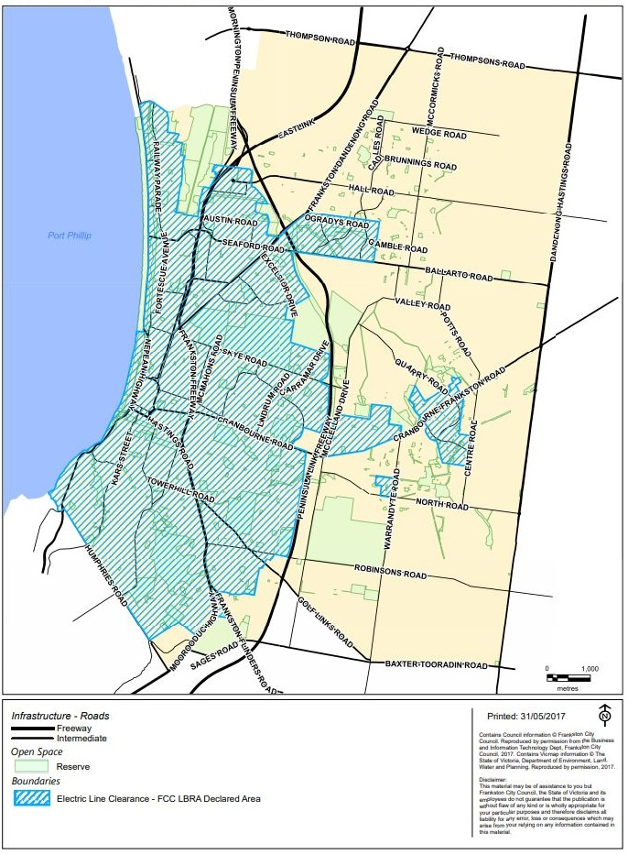

**Printed 31/03/2021**

## **Appendix 2 - High Bushfire Risk Area (HBRA) of Frankston City**

## 

## Appendix 3: Register of Significant Trees on Public Land – Current

|  |  |  |  |  |  |  |
| --- | --- | --- | --- | --- | --- | --- |
| **Address** | **Location** | | | | **Species** | **Significance Category** |
| 48 | Airlie | Grove | Seaford | Seaford Wetlands | *Eucalyptus camaldulensis* | Aboriginal Culture |
| 45 | Aqueduct | Road | Langwarrin | Nature Strip | *Eucalyptus obliqua* | Remnant Outstanding size Outstanding habitat |
| 3/1R | Bentley | Place | Frankston | Montague Park Pre-School | *Populus species* | Outstanding size |
| 8 | Cambridge | Street | Frankston | Nature Strip | *Angophora costata* | Outstanding size; Aesthetic value |
| 20 | Cambridge | Street | Frankston | Nature Strip | *Angophora costata* | Aesthetic value; Location or Landscape Context |
| 1 | Chile | Street | Frankston | Outer Separator | *Eucalyptus globulus* | Outstanding size; Aesthetic value. |
| 53 | Dandenong East | Road | Frankston | Nature Strip | *Angophora costata* | Outstanding Size; Aesthetic Value |
| 10-18 | Davey | Street | Frankston | Nature Strip ( 7 Trees) | *Norfolk Island Pines* | Outstanding size; Amenity value |
| 48 | Deane | Street | Frankston | Nature Strip | *Eucalyptus leucoxylon* | Aesthetic value; Outstanding Size |
| 10 | Eel Race | Road | Seaford | Outer Separator | *Banksia integrifolia* | Outstanding size; Aesthetic value |
| 30 | Foot | Street | Frankston | Oxford St Car park | *Angophora costata* | Outstanding size; Aesthetic value; Curious Growth |
| 15 | Frome | Avenue | Frankston | Nature Strip | *Angophora costata* | Outstanding size; Aesthetic value |
| 27 | Frome | Avenue | Frankston | Nature Strip | *Angophora costata* | Outstanding size; Aesthetic value |
| 31 | Frome | Avenue | Frankston | Nature Strip | *Angophora costata* | Outstanding size; Aesthetic value |
| 35 | Frome | Avenue | Frankston | Nature Strip | *Angophora costata* | Aesthetic value; Location or Landscape |
| 43 | Frome | Avenue | Frankston | Nature Strip | *Angophora costata* | Aesthetic value; Location or Landscape |
| 21 | Gould | Street | Frankston | Nature Strip (3 Trees) | *Leptospermum laevigatum* | Curious Growth Form |
| 1 | Hayman | Avenue | Frankston | Nature Strip | *Arbutus unedo* | Rare or Localised; Amenity value |
| 44R | Herbert | Road | Carrum Downs | Herbert Reserve - near playground | *Eucalyptus camaldulensis* | Aesthetic value; Remnant; |
| 3N | High | Street | Frankston | Nature Strip - Plowman Place (16 Trees) | *Monterey Cypress* | Location or Landscape context |
| 51N | High | Street | Frankston | Beauty Park (6 Trees) | *Populus deltoides* | Location or Landscape context |
| 29 | Hill | Street | Frankston | Nature Strip | *Melaleuca stypholoides* | Outstanding Size |
| 83R | Hillcrest | Road | Frankston | Jubilee Park - Hill St | *Eucalyptus camaldulensis* | Location or Landscape context |
| 83R | Hillcrest | Road | Frankston | Jubilee Park 3 Trees | *Banksia integrifolia* | Remnant |
| 83R | Hillcrest | Road | Frankston | Jubilee Park - car park | *Banksia integrifolia* | Outstanding example of a species |
|  | Long Island | Drive | Frankston | Playne St bridge | *Phoenix canariensis* | Location or Landscape context |
| 47R | Luscumbe | Avenue | Carrum Downs | Banyan Reserve | *Eucalyptus camaldulensis* | Particularly old; Remnant; Aboriginal culture |
| 14N | Monterey | Boulevard | Frankston North | Monterey Reserve | *Corymbia maculata* | Aesthetic Value |
| 490 | Nepean | Highway | Frankston | Median Strip | *Cupressus macrocarpa* | Particularly old; Historic value |
| 508 | Nepean | Highway | Frankston | Median Strip | *Cupressus macrocarpa* | Particularly old; Historic value |
| 4 | Park | Street | Seaford | Nature Strip | *Eucalyptus camaldulensis* | Aesthetic Value; Rare or Localised |
| 1N | Plowman | Place | Frankston | Mechanics Hall | *Canary Island Palm* | Location or Landscape context |

## Appendix 4 - Two Year Cyclic Pruning Schedule

<http://www.frankston.vic.gov.au/Your_Council/Media_and_Publications/Latest_News/Tree_Management_Program>

|  |  |  |  |  |  |
| --- | --- | --- | --- | --- | --- |
| **Zone Description** | **Zone Number** | **2020** | **2021** | **2022** | **2023** |
| Month/s Scheduled | Month/s Scheduled | Month/s Scheduled | Month/s Scheduled |
| **Langwarrin Nth** | 10 | January |  | January |  |
| **Langwarrin Sth** | 19 | February |  | February |  |
| **Fleetwood (Frankston Sth)** | 20 | March |  | March |  |
| **Langwarrin Sth (inc Rural)** | 24 | April |  | April |  |
| **Langwarrin Sth (inc Rural)** | 18 | May |  | May |  |
| **Hartnett Dve (S'ford East)** | 2 | June |  | June |  |
| **Rosedale Gve, (F'ton Sth)** | 22 | July |  | July |  |
| **Lyrebird Dve, C/Downs** | 4 | August |  | August |  |
| **Stotts Lane, Fton Sth** | 23 | September |  | September |  |
| **Kars St , Frankston** | 15 | October |  | October |  |
| **Railway Pde, Seaford Nth** | 1 | November |  | November |  |
| **Central Business District** | 0 | December |  | December |  |
| **Carrum Downs/Skye** | 5 | December |  | December |  |
| **Seaview Rd, F'ton Sth** | 21 |  | January |  | January |
| **Hadley St, S/F East** | 8 |  | February |  | February |
| **Gamble Rd, C/Downs** | 6 a & b |  | March |  | March |
| **Heatherhill, Frankston** | 17 a & b |  | April |  | April |
| **Leawarra Pde, Frankston** | 14 |  | May |  | May |
| **Carramar Dve, Karingal** | 13 |  | June |  | June |
| **Ashleigh Ave, Karingal** | 11 a & b |  | July |  | July |
| **Karingal Dve, Karingal** | 12 |  | August |  | August |
| **Buna Ave, Seaford** | 7 |  | September |  | September |
| **Pines** | 9 |  | October |  | October |
| **Lathams Rd, Seaford East** | 3 |  | November |  | November |
| **Foot St, Frankston** | 16 |  | December |  | December |
| **Central Business District** | 0 |  | December |  | December |
|  |  |  |  |  |  |
| **Rural Roads** |  | November- December | November- December | November- December | November- December |
| **Pre-schools** | (1/4) | Term 1-2 School Holidays | Term 1-2 School Holidays | Term 1-2 School Holidays | Term 1-2 School Holidays |
| **Preschools** | (2/4) | Term 2-3 School Holidays | Term 2-3 School Holidays s | Term 2-3 School Holidays | Term 2-3 School Holidays |
| **Preschools** | (3/4) | Term 3-4 School Holidays | Term 3-4 School Holidays | Term 3-4 School Holidays | Term 3-4 School Holidays |
| **Preschools** | (4/4) | Term 4-1 School Holidays | Term 1-2 School Holidays | Term 1-2 School Holidays | Term 1-2 School Holidays |

## Appendix 5 - Map of 24 Road Management Plan (RMP) zones

## Appendix 6 - Maintaining a minimum clearance space

### Figure 1 – Plan view of Electrical lines in all areas

### 

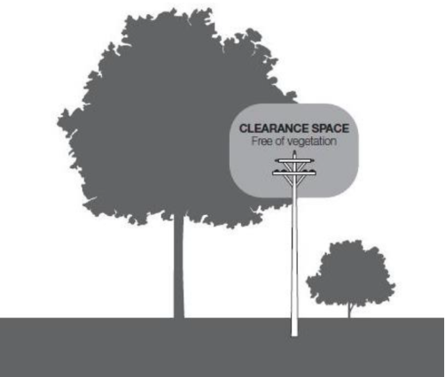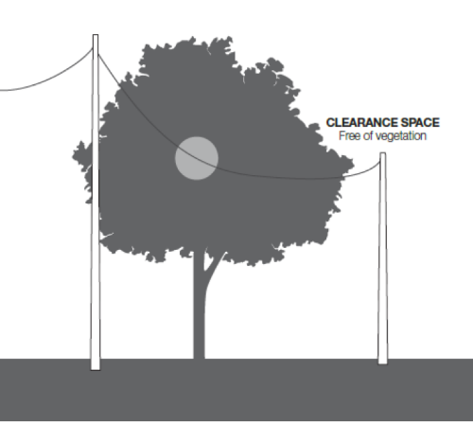

### Figure 2 – Insulated Electric lines in all areas

### Figure 3 – Insulated Electric lines in all areas and uninsulated high voltage electric lines (other than 66,000 volt electric lines) in Low Bushfire Risk Area

### Graph 4: Uninsulated 66,000 volt electric line in Low Bushfire Risk Area

The applicable distance for the middle 2 thirds of the span is represented as a graph in Graph 4 of Schedule 2 of the Electricity Safety (Electric Line Clearance) Regulation 2020.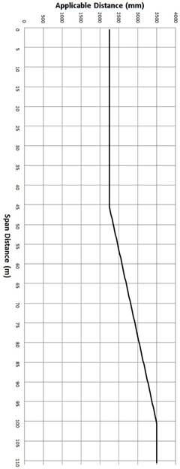

## Appendix 6 - Predominate FCC tree species regrowth pruning guidance chart

|  |  |  |  |  |  |  |  |
| --- | --- | --- | --- | --- | --- | --- | --- |
|  |  | **Tip prune** | | | **Valley prune** | | |
| **Species** |  | Estimated annual regrowth | Regrowth allowance 1 year cycle | Regrowth allowance 2 year cycle | Estimated annual regrowth | Regrowth allowance 1 year cycle | Regrowth allowance 2 year cycle |
| ***Acacia longifolia/sophorae*** | TO | 1 | 1 | 2 | 1 | 1 | 2 |
| ***Acacia melanoxylon*** |  | 1 | 1 | 1.5 | 1 | 1 | 1.5 |
| ***Agonis flexuosa*** | TR | 1 | 1 | 1.5 | 1 | 1 | 2 |
| ***Angophora costata\**** |  | 1 | 1 | 1.5 | 1 | 1 | 2 |
| ***Banksia integrifolia*** | TO | 1 | 1 | 2 | 1 | 1 | 2 |
| ***Callistemon* sp.** | TO | 0.5 | 0.5 | 1 | 0.5 | 0.5 | 1 |
| ***Corymbia ficifolia*** | TO,TR | 0.5 | 0.5 | 1 | 1 | 1 | 2 |
| ***Eucalyptus cornuta\**** | TR | na | na | na | 2 | 1 | 2 |
| ***Eucalyptus leucoxylon*** | TR | na | na | na | 1.5 | 1 | 2.5 |
| ***Eucalyptus leucoxylon dwarf varieties*** |  | 0.5 | 0.5 | 1 | na | na | na |
| ***Eucalyptus nicholii\**** | TR | na | na | na | 1 | 1 | 1.5 |
| ***Eucalyptus ovata\**** |  | 1 | 1 | 1.5 | 1 | 1 | 1.5 |
| ***Eucalyptus pryoriana*** |  | 1 | 1 | 2 | 1 | 1 | 2 |
| ***Eucalyptus radiata\**** |  | 1 | 1 | 2 | 1 | 1 | 2 |
| ***Fraxinus* sp.\*** | TR | 1 | 1 | 2 | 1.5 | 1.5 | 3 |
| ***Grevillea robusta\**** |  | na | na | na | 1 | 1 | 2 |
| ***Hakea salicifolia*** | TO | 0.5 | 0.5 | 0.5 | na | na | na |
| ***Lagunaria patersonii\**** | TR | 0.5 | 1 | 1 | 0.5 | 1 | 1 |
| ***Leptospermum laevigatum*** | TO | 0.5 | 0.5 | 0.5 | na | na | na |
| ***Liquidambar styraciflua\**** |  | 1 | 1 | 2 | 1 | 1.5 | 3 |
| ***Lophostemon confertus\**** | TR | 1 | 1 | 2 | 1.5 | 1.5 | 3 |
| ***Melaleuca armillaris*** | TO | 0.5 | 0.5 | 1 | 0.5 | 0.5 | 1 |
| ***Melaleuca linariifolia\**** | TO | 0.5 | 0.5 | 1 | 0.5 | 0.5 | 1 |
| ***Melaleuca styphelioides\**** | TO | 0.5 | 0.5 | 1 | 0.5 | 0.5 | 1 |
| ***Melia azedarach*** | TO,TR | 1 | 1 | 2 | 1 | 1 | 2 |
| ***Pittosprum undulatum\**** |  | 0.5 | 1 | 2 | 0.5 | 1 | 2 |
| ***Tristaniopsis laurina*** | TO | 0.5 | 0.5 | 0.5 | 0.5 | 0.5 | 0.5 |
|  | | | | | | | |
| **All measurements in metres (m)** | | | | | | | |
| **Blue where regrowth exceeds 2 year cyclic program, annual prune is included in contract for worst cases** | | | | | | | |
| **TO = Tip prune only, valley pruning not recommended for this species** | | | | | | | |

## Appendix 7 – United Energy Audits of FCC compliance and cost for non-compliance

2013 rating FCC as 2nd out of 14 ORP within its network. No further audit ratings supplied by UE since 2013.

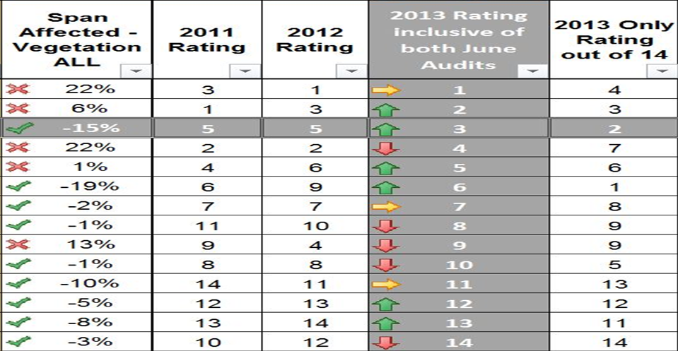

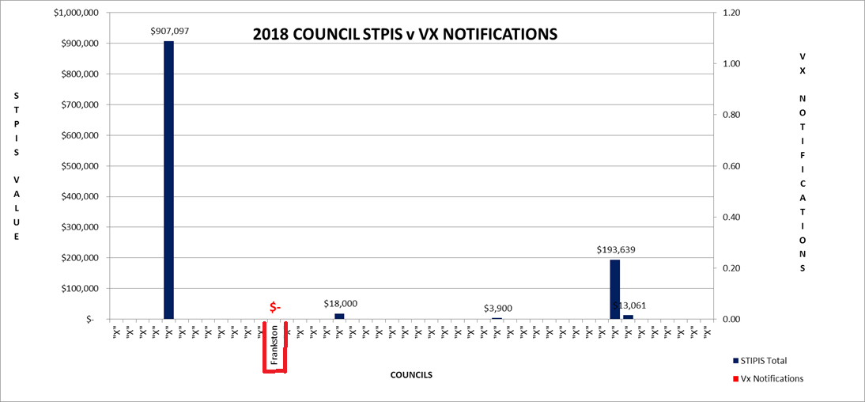UE Service Target Performance Incentive Scheme costs for non-compliant LGAs 2018

## Appendix 8 - Frankston City Council Location and Records of power line audits

### 8A- Municipality map showing historic data and current power line audit sites

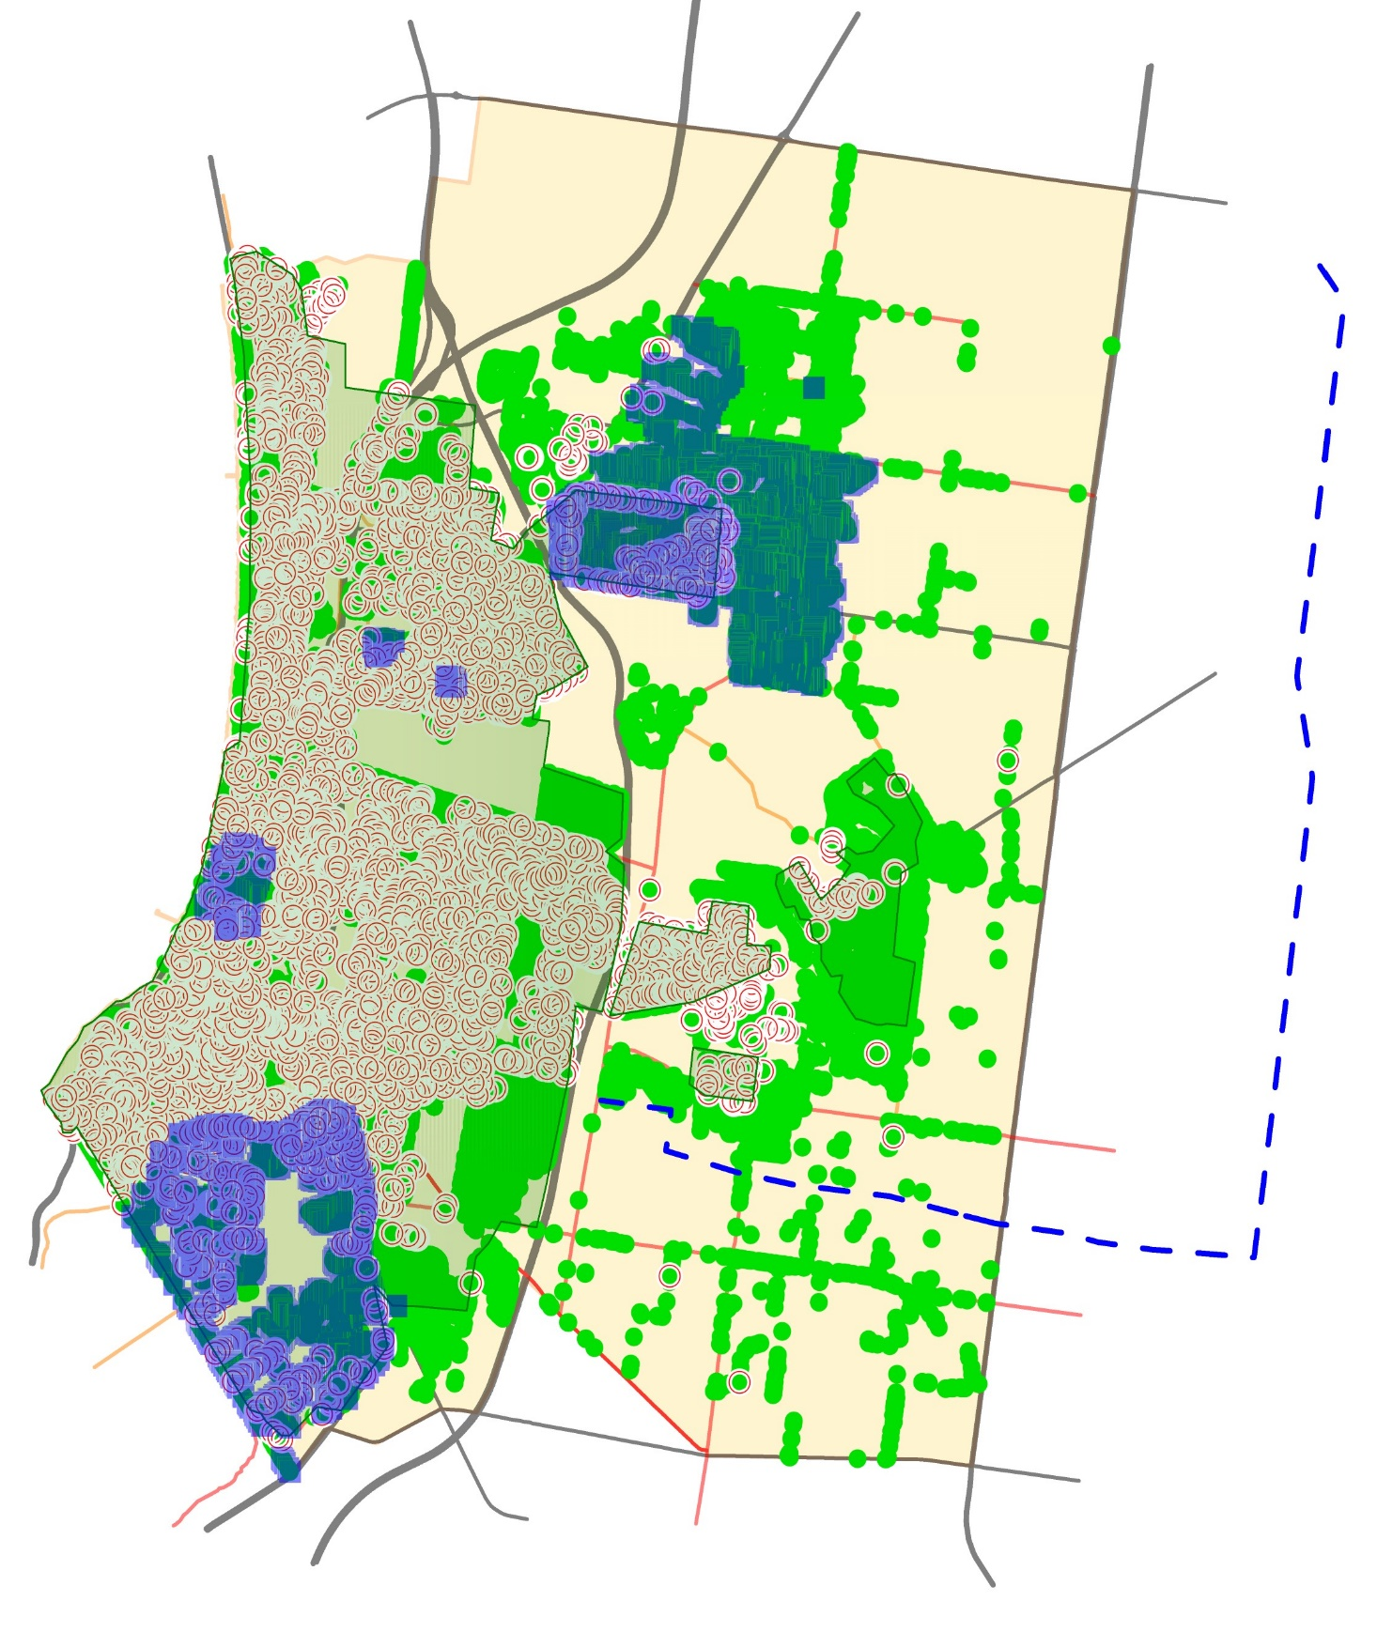

### 8B - Zoomed in map of unique location of trees including pre-works inspection for electrical line clearance rectification

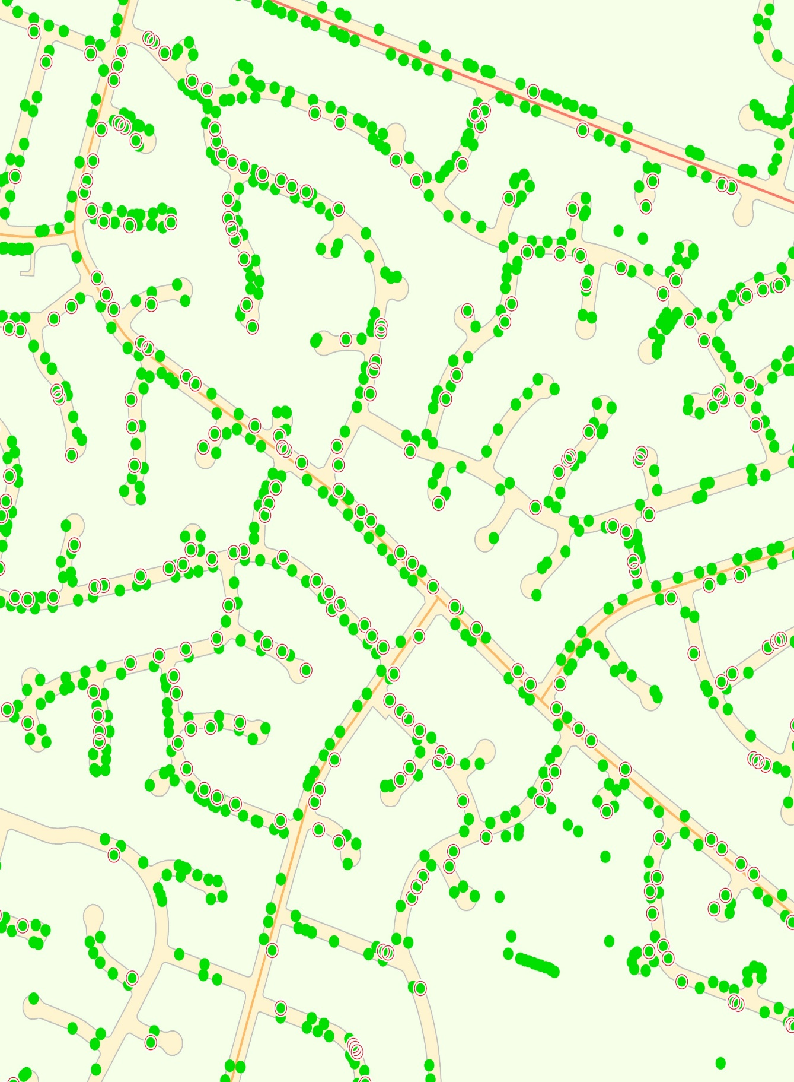

### 8C - Extract from Asset management system post-work generated audit

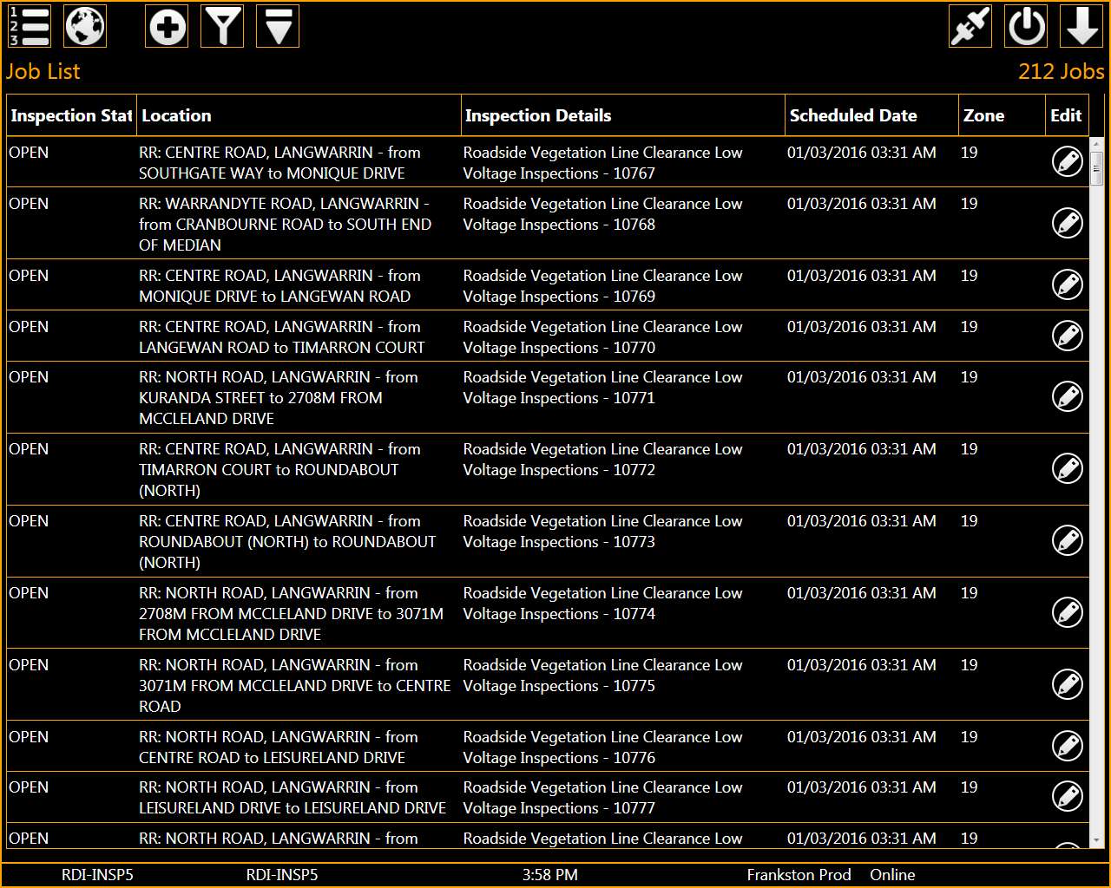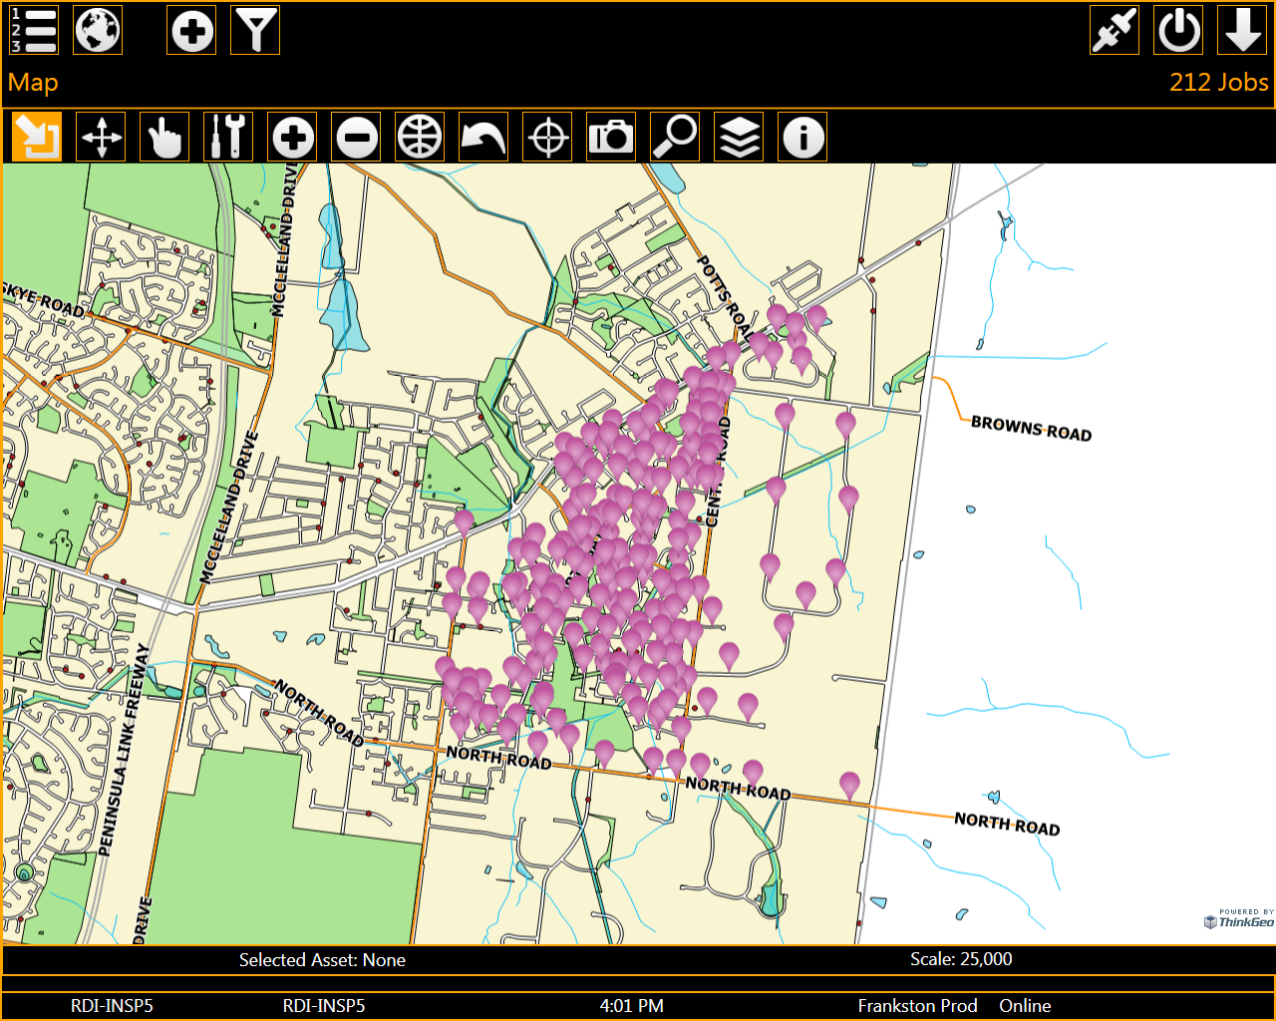

## Appendix 9 - Staff training matrix example

Full details restricted, further information available upon request by ESV



## Appendix 10 – Field Audits and KPI’s

### 10A - Monthly field Audit example

|  |  |  |
| --- | --- | --- |
| **WORKPLACE INSPECTION CONTRACTOR** | | |
| **DATE 10/12/22** |  |  |
| **OFFICER Derek Lynn** |  |  |
| **AUDITOR Derek Lynn** |  |  |
| **LOCATION Carrum downs Skye zone 5 Time** | 1230pm |  |
| **TASK BEING PERFORMED Tree works** |  |  |
| **SITE MANAGEMENT** |  |  |
| Signs displayed correctly as per TMPs | yes |  |
| Vehicle parked appropriately | yes |  |
| No unnecessary disturbance to the public |  | No |
| Correct tools for task be preformed | yes |  |
| **PERSONNEL SAFETY** |  |  |
| Orange vest being worn (if applicable) | yes |  |
| Machinery being used correctly | yes |  |
| Appropriate PPE being worn | Yes |  |
| Appropriate SWMS signed for the work being performed (check SWMS register prior) | Yes |  |
| Adherence to ESI Cert 11 training and blue book regulations | Yes |  |
| Corrective action required:  None seen. Spoke to 3 crew quizzing ESI 2 training and valued take home from that. Response about cutting heavy limbs to step cut 1st under and the final on top and on the tree side to avoid saw being pulled from operator. And a recant the new limits tree body and gear to lines. |  |  |
|  |  |  |
| Comments |  |  |
|  |  |  |
|  |  |  |

### 10B - Table example outlining contract program KPIs

|  |  |  |  |  |  |
| --- | --- | --- | --- | --- | --- |
| **CONTRACT 2016/17-66 - PROVISION OF TREE MAINTENANCE SERVICES** | | | | | |
| CONTRACTOR: | **THE TREE DOCTOR PTY. LTD** | | | | |
| **MONTHLY KPI REPORTING** | | | **MARCH** | **2018** | |
| **Key Performance Indicator** | | **Measurement Tool** | **Target Measurement** | **Rating** | **Category 1** |
| Adherence to programme timing and delivery | | Contractor reporting; | All within target adverse weather permitting | 10 | **5.00** |
| Internal and/or external audit results |  5% not complete | 7.5 |
|  |  10% not complete | 5 |
|  |  10% not complete | 0 |
| Timely advice to Contract Supervisor of programme / project / works slippage | | Contractor reporting; | Advice at time known | 10 | **10.00** |
| Internal and/or external audit results | Advice within 24 hours | 7.5 |
| Communications | Advice within 1 working day | 5 |
|  | Advice  1 working day | 0 |
| Works quality | | Audit | Zero defects | 10 | **10.00** |
| Complaints |  4 defects | 7.5 |
| Feedback |  6 defects | 5 |
|  |  6 defects | 0 |
| Staff training, qualifications and licensing (where applicable) up to date | | Qualification certification | Zero failures | 10 | **10.00** |
| Training certification |  4 failures | 7.5 |
| Licenses |  6 failures | 5 |
| Refreshers |  6 failures | 0 |
| Reporting timeliness and quality | |  | On time and zero corrections | 10 | **10.00** |
| Report receipt | On time and <3 corrections | 7.5 |
|  | Late and <3 corrections | 5 |
| Corrections required | Late and >3 corrections | 0 |
| Complaints (upheld) | | Complaints investigation outcome | Zero complaints | 10 | **10.00** |
| 1 complaint | 7.5 |
| 2 complaints | 5 |
| >2 complaints | 0 |
| Safety (Works) related injuries | | Safety incidents and near misses recorded during period | Zero Incidents | 10 | **10.00** |
| (Incident Reporting) | | 1- 2 same / near miss repeated | 5 |
|  | |  3 near misses repeated or 1 incident | 0 |
| Completion of Risk Inspection / SWMS & OH&S documentation prior to commencement of works | | Audit of compliance, reports submitted as per contract requirements | Compliant | 10 | **10.00** |
|  1 Incomplete documentation | 5 |
|  1 incident of no documentation a works job | 0 |
|  | |  | **TOTAL MONTHLY SCORE** |  | **95.00** |

## **Appendix 11 - Resident notification letters & tree maintenance web page**

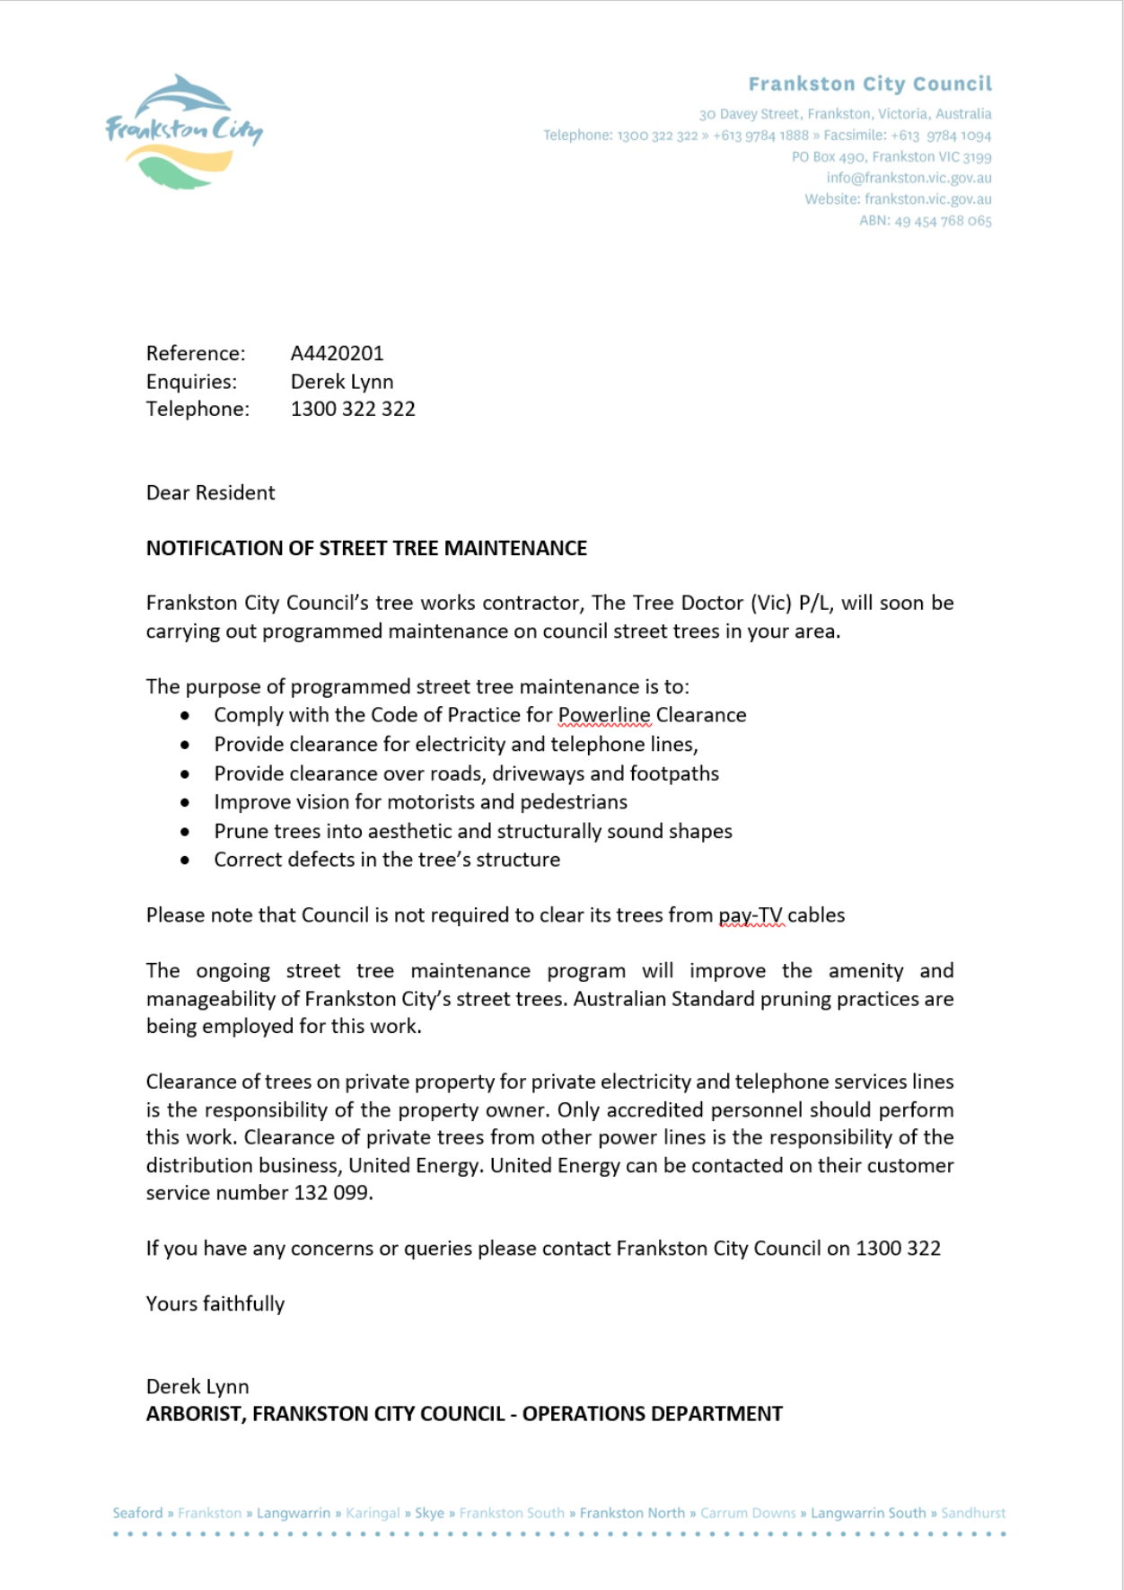

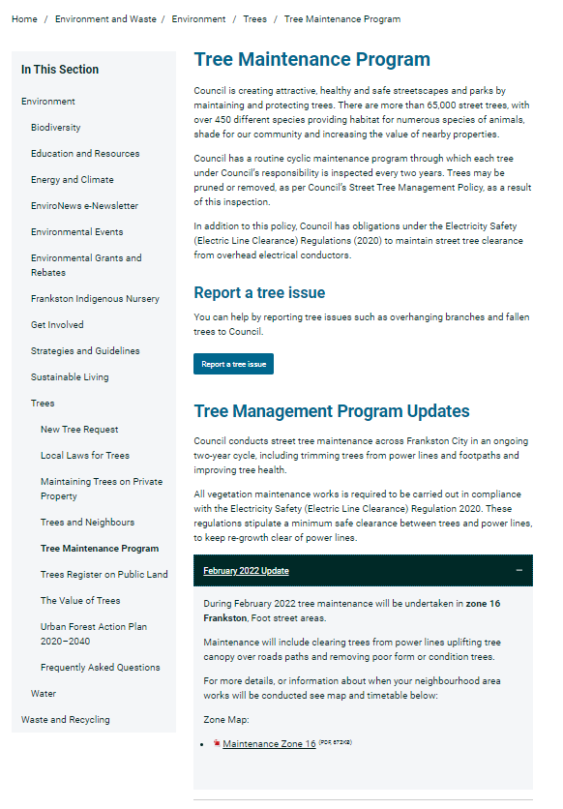

#### 

<https://www.frankston.vic.gov.au/Your_Council/Media_and_Publications/Latest_News/Tree_Management_Program_Updates>